**Real-time Face Mask Detection**

Report

Experiential Learning/Case Study/ Course Project

GROUP-28

**NAME**  **EMAIL REGD. NO**

|  |
| --- |
| **Rana Sujeet Kumar** [**2101020306@cgu-odisha.ac.in**](mailto:2101020306@cgu-odisha.ac.in) **2101020306**  **Priya Ranjan 2101020446@cgu-odisha.ac.in 2101020446**  **Divy Prakash Tiwari** [**2101020449@cgu-odisha.ac.in**](mailto:2101020449@cgu-odisha.ac.in) **2101020449**  **Mahendra Singh** [**2101020451@cgu-odisha.ac.in**](mailto:2101020451@cgu-odisha.ac.in) **2101020451** |

Guided by:

**Dr. lazrus**

**Asst. Prof., Dept. of CSE,CGU,ODISHA.**



**Department of Computer Science and Engineering**

**C.V. Raman Global University, Bhubaneswar**

**Odisha, 752054, India**

**Acknowledgement**

We would wish to thank everyone who had helped to the great finishing of this project.   
We would like to show our thanks for project guide Mr. lazarus. Assistant Professor in Computer Science and Engineering Department who gave useful ideas for our project. We express our deep felt thanks to beloved HOD, someone, Head of the Department for giving necessary information regarding the project and also her help in finishing it. We also thank our Project Coordinator, Lazarus , Assistant Professor who gave expert direction, support and critical feedback amidst his busy schedule throughout the project. We also great full to all the authors of books and papers which have been mentioned to print this paper

**Abstract**

Human lives have been changed in numerous ways by the growth of covid 19. People have been hurt physically, mentally and financially as well. People refuse to wear face masks most of the time, and this allows the virus to spread from human to human via drops and airborne. The only way to stop this outbreak is by wearing face masks, keeping a safe distance, and taking preventative steps. Wearing a mask in public places would be helpful for lowering this situation. We suggested a face mask recognition method using the YOLO V5 algorithm in our work to ensure everyone is wearing a face mask properly. YOLO is an anagram for the saying "You Only Look Once". Real-time identification and classification of various items in a picture is achieved with this method. A regression problem is used in YOLO to identify the items and to measure their probabilities. With its fast and effective object spotting method, it is the state-of-the-art in object recognition. YOLO offers superb speed, allowing fast and accurate recognition. With its speed of more than 11 frames per second, it can handle a huge amount of data fast.

**INTRODUCTION**

This groundbreaking project uses the formidable power of Deep Neural Networks (DNNs), specifically applying the sophisticated design of a Convolutional Neural Network (CNN), to face the pressing task of separating people wearing masks from those without. In an age marked by the necessity of public health and safety, such technical advances stand as bulwarks against the spread of dangerous illnesses.

The CNN at the heart of this effort displays remarkable ability, having an awe-inspiring accuracy of 98.2% on the training set and 97.3% on the formidable test set.

Real-time application for detecting and recognizing faces with the use of the YOLO method. YOLO is a proven object detection algorithm with state-of-the-art features. According to the results of the experiments, yolo-based face detection is more robust and faster at detecting faces. Excellent detection accuracy is ensured even in complex settings. The detection speed and real-time detection requirements can coexist simultaneously. This is a relatively trivial problem that can be solved by human beings and by classical feature-based techniques like the cascade classifier. A recent study on a standard benchmark dataset for face detection revealed state-of-the-art results from deep learning techniques. model's capacity committed to honing its predictive ability on the training set, while the remaining 20% is saved for the harsh furnace of the test set.

The results of this hard attempt are nothing short of extraordinary, with the model reaching a staggering accuracy of 98.2% on the training set, a testament to its adeptness at identifying the complex patterns buried within the data. Yet, even in the furnace of the test set, where the model is exposed to the harsh analysis of unknown data, its performance stays resolute, having an amazing accuracy of 97.3%.

YOLO (You Only Look Once)

YOLO is an algorithm that uses neural networks to provide real-time object detection. This algorithm is popular because of its speed and accuracy. It has been used in various applications to detect traffic signals, people, parking meters, and animals. This is an algorithm that detects and recognizes various objects in a picture (in real-time). Object detection in YOLO is done as a regression problem and provides the class probabilities of the detected images.

YOLO algorithm employs convolutional neural networks (CNN) to detect objects in real-time. As the name suggests, the algorithm requires only a single forward propagation through a neural network to detect objects. This means that prediction in the entire image is done in a single algorithm run. The CNN is used to predict various class probabilities and bounding boxes simultaneously. The YOLO algorithm consists of various variants. Some of the common ones include tiny YOLO and YOLOv3. YOLO algorithm is important because of the following reasons,

Speed: This algorithm improves the speed of detection because it can predict objects in real-time. High accuracy: YOLO is a predictive technique that provides accurate results with minimal background errors.

Learning capabilities: The algorithm has excellent learning capabilities that enable it to learn the representations of objects and apply them in object detection.

We are employing Version 5, which was launched by Ultralytics in June 2020 and is now the most advanced object identification algorithm available. It is a novel convolutional neural network (CNN) that detects objects in real-time with great accuracy. This approach uses a single neural network to process the entire picture, then separates it into parts and predicts bounding boxes and probabilities for each component. These bounding boxes are weighted by the expected probability. The method “just looks once” at the image in the sense that it makes predictions after only one forward propagation run through the neural network. It then delivers detected items after non-max suppression (which ensures that the object detection algorithm only identifies each object once). The initial release of YOLOv5 is very fast, performant, and easy to use. YOLOv5 is very user friendly and comes ready to use on custom objects "out of the box". YOLOv5 derives most of its performance improvement from PyTorch training procedures, while the model architecture remains close to YOLOv4. the goal is to produce an object detector model that is very performant (Y-axis) relative to its inference time (X-axis).

**DATASET USED**

1. About The Dataset

The Face Mask Detection Dataset is a selected collection of 1376 pictures especially made for training and testing deep learning models intended to identify the presence or lack of face masks on human subjects. With 690 pictures showing individuals wearing masks and 686 images depicting individuals without masks, this dataset offers a fair and diverse representation of real-world settings.

**Dataset Characteristics:**   
1. Total Images: 1376   
2. Masked Individuals: 690 pictures   
3. Unmasked Individuals: 686 pictures   
4. Image Resolution: Varied   
5. File Format: JPEG

1. **Usage:**   
   This dataset serves as an ideal resource for individuals keen on discovering and understanding deep learning methods for face mask recognition. Whether you're a student, researcher, or amateur, this dataset offers a good base for working with convolutional neural networks (CNNs) and other advanced machine learning methods.

* **Potential Applications:**

1. Development of automated face mask recognition devices for public areas, jobs, and healthcare facilities.  
2. Integration with security cams for real-time tracking and execution of mask-wearing rules.   
3. Enhancement of current security systems with clever mask recognition capabilities.

* **Data Integrity and Quality:**   
    
  1. The pictures in this dataset have been carefully selected and named to ensure correctness and usefulness.   
  2. Special focus has been paid to varied groups, face emotions, and weather conditions to enhance model stability and generalization.

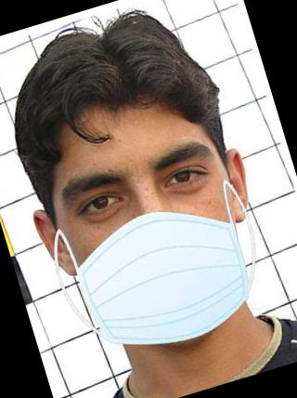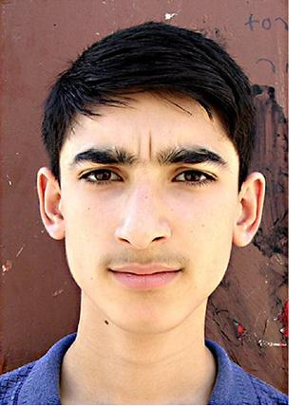

With Mask

Without Mask

**Methodology:**

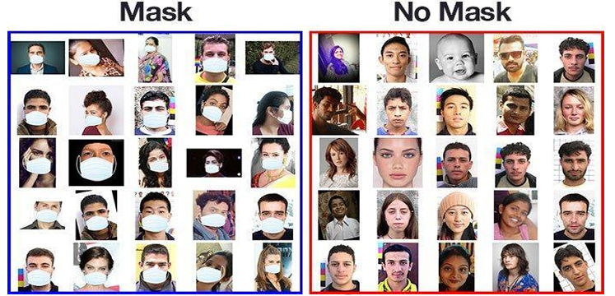This section will present the experiment results of the face mask detection using YOLO V5 in real- time application. A GUI (Graphical User Interface) will be created by using Tkinter. The Data preparation was first to load face images with and without mask (figure 2), then annotate bounding box of each vehicle in an image and save annotated images and labels. Initializing yolo network and generating training and testing datasets. We are using a publicly available dataset to train our model. Training in Load images and annotated labels, then Train yolo and save trained model. After training, Testing of the datasets can be implemented. Test the Load configuration and weight file of trained yolo and Input image to loaded model. Then Detect mask stratus in the image and shows the result

**Results:**

**Reference**

[1] W. Yang and Z. Jiachun, "Real-time face detection based on YOLO", 2018 1st IEEE International

Conference on Knowledge Innovation and Invention (ICKII), pp. 221-224, 2018.

[2] C. Liu, Y. Tao, J. Liang, K. Li and Y. Chen, "Object detection based on YOLO network", 2018

IEEE 4th Information Technology and Mechatronics Engineering Conference (ITOEC), pp. 799-803,

2018.

[3] D. Garg, P. Goel, S. Pandya, A. Ganatra and K. Kotecha, "A deep learning approach for face

detection using YOLO", 2018 IEEE Punecon, pp. 1-4, 2018.

[4] C. Zhao and B. Chen, "Real-time pedestrian detection based on improved YOLO model", 11th

International Conference on Intelligent Human-Machine Systems and Cybernetics (IHMSC), pp. 25-28,

2019.

[5] J. Redmon and A. Farhadi, YOLO9000: Better Faster Stronger, 2016.

[6] C. Kim et al., "Implementation of Yolo-v2 image recognition and other testbenches for a CNN

accelerator", 2019 IEEE 9th International Conference on Consumer Electronics (ICCE-Berlin), pp.

242-247, 2019.

[7] S Susanto, FA Putra, R Analia..,"The Face Mask Detection For Preventing the

Spread of COVID-19 at Politeknik Negeri Batam”-2020 3rd International …, 2020 -

ieeexplore.ieee.org.

[8] J. Redmon and A. Farhadi, YOLOv3: An Incremental Improvement, 2018.

[9] A. Bochkovskiy, C-Y. Wang, and H-Y. M. Liao, YOLOv4: Optimal Speed and

Accuracy of Object Detection, 2020.